10/24/2011
Spotlight: NXTdim PDM
It's been a while, but I have a new spotlight feature for everyone. This one is called NXTdim PDM, and it comes to us from Cadac Group.

From the creators:
Expand your Vault Job Server capabilities with two major Jobs Types:
Secondary Documents - Automatically create several types of export files and add them as Secondary Documents (attachment) to your vaulted Inventor files. The Job can create all the export types you need in one go. You can make your own configuration for every Inventor Document Type and enforce the setting for all Vault Clients.
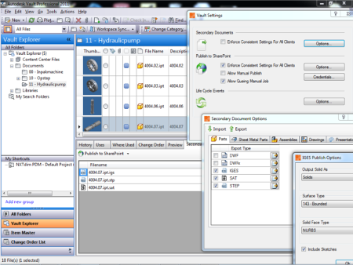
(click image for larger view)
Publish to SharePoint - Publish your Secondary Documents to one or more SharePoint Libraries. Each export file type of every Inventor document type can be uploaded to the SharePoint Library you want. You can even control the filename of the uploaded document and make mappings between iProperties and SharePoint Library Properties. Besides automatically queuing of the job on status change, there is an option to perform manual uploads as well.
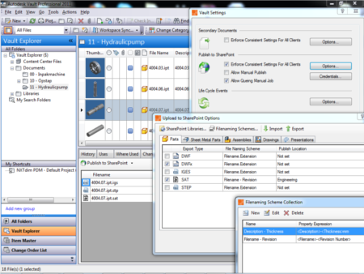
(click image for larger view)
Product URL: http://www.nxtdim.com
Product videos: http://video.nxtdim.com/?app=3


About the company:
Cadac Group specializes in providing IT solutions to create, manage and share digital design information.
The internationally oriented Cadac Group with branches in Europe, United Stated and Australia specializes in providing automated solutions for creating, managing and sharing digital design information. In addition, Cadac Group, is an independent in-house developer of software for Autodesk Inventor, Autodesk Revit and applications on the Microsoft SharePoint Platform. The Cadac Organice Product Suite is applied successfully all over the world, in particular by project-oriented organizations. Cadac Group has a reputation as a reliable and pragmatic partner for its clients, with a focus on helping them to improve their design processes and project communication. Cadac Group is an Autodesk Premier Solution Provider, Microsoft Gold Certified Partner and Oracle Certified Partner.

If you want your product to be featured in my Spotlight section, send an email to doug.redmond AT autodesk.com.

